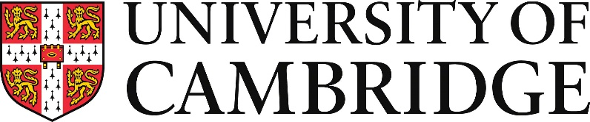

June 2021
Dear Offer Holder,
I am writing to inform our offer holders how we are planning for the next academic year.
The University and Colleges of Cambridge are preparing to welcome students – undergraduate and postgraduate – to Cambridge for the academic year 2021/22. We remain committed to excellence in education, learning and research. Every College remains proud to be their students’ Cambridge home, and looks forward to welcoming new students into their College community.
Cambridge is committed to offering students the fullest possible educational and student experience. The Collegiate University provides a deep-rooted sense of community and rich opportunities for learning. Small group teaching – supervisions, seminars or individual tuition – is at the heart of our educational provision and will continue in person to the extent that this is allowed by public health requirements.
The Collegiate University sets out below its principles for delivering education in the academic year 2021/22. We continue to respond to the changing public health situation and will continue to review our approach. More detailed information will be provided to students by the end of July; these principles offer a guide to our current plans:
- Cambridge will be open to students next academic year.
- The academic year will start at the normal time and term dates remain unchanged.
Michaelmas Term will start on Tuesday 5 October and end on Friday 3 December. New and returning undergraduate and postgraduate students are advised to be flexible in their travel plans at this stage; more advice about arrangements for the start of term will follow in July.
- Students will be expected to be in Cambridge for the start of the academic year, subject to any requirements to stagger the arrival of students and any unforeseen difficulties travelling to Cambridge. We know that there may be compelling reasons why a student cannot be in Cambridge. Details on the University’s policy on temporary permission to study remotely is available on the University’s coronavirus webpages.
- We expect to deliver our small-group teaching and practicals in-person where public
health requirements allow, and subject to local risk assessment. At this time, it is not clear whether it will be possible to deliver larger lectures in-person: we are therefore planning to be able to do this either in-person or online, and will review this over the summer.
- Students will be given full access to learning facilities, including laboratories, libraries and museums wherever possible, with appropriate safety measures in place.
- Minimising risk: the University and Colleges will continue to risk assess buildings and activities. Students can expect to find appropriate cleaning regimes in place and where necessary restrictions to the number of people allowed to gather. In some areas, students may be expected to wear face coverings unless they are exempt. We will provide COVID-19 tests to students on their arrival in Cambridge and arrange appropriate testing as required throughout the academic year. We strongly encourage students to book their vaccine as soon as possible to protect themselves and others. Further information is available at Vaccination | University of Cambridge.
- International students and visas: The majority of UK Visa Application Centres are open around the world and student visa processing is continuing as usual. If you require a student visa for your studies and have any questions about the application process or requirements, contact the International Student Office.
- Support: The Colleges will continue to offer pastoral support to their students; the University additionally will continue to provide centralised student support, including the Student Counselling Service, Disability Resource Centre, Careers Service, support for mature students, student parents and care leavers. These services will continue to be provided, either in person or via real time face-to-face technology. For more information on our welfare support, see www.studentwellbeing.admin.cam.ac.uk/ and your own College’s website.

With best wishes,
Graham
Professor Graham Virgo
Senior Pro-Vice-Chancellor (Education)

