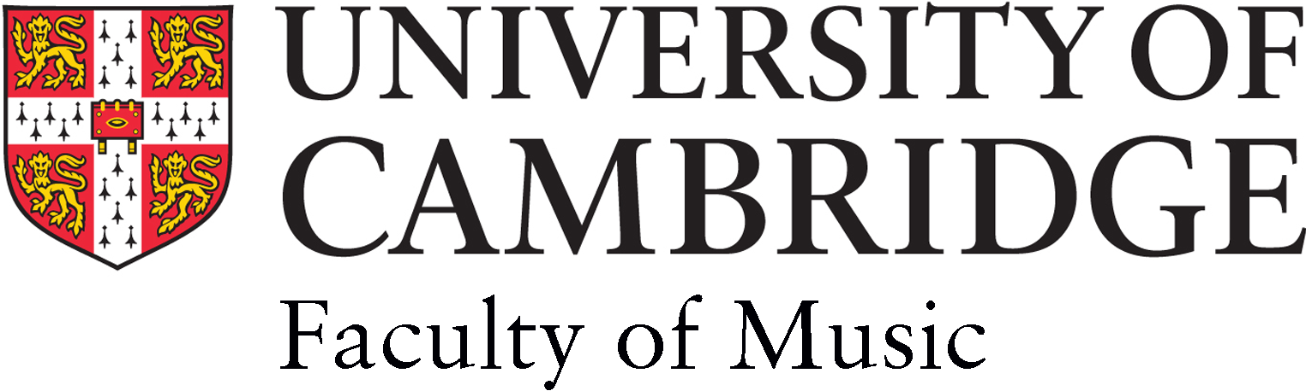

PARENT/ LEGAL GUARDIAN CONSENT/RELEASE FORM *:
PHOTO / VIDEO / FILM / SOUND RECORDING

* Parental/Legal Guardian permission and consent is required for:
a ‘child’ – a person under the age of 16;
a ‘vulnerable adult’ - a person aged 16 or over whose ability to protect himself or herself
from neglect, abuse or violence is significantly impaired on account of disability, illness
or otherwise.

EVENT/ACTIVITY/PROJECT TITLE: The Cambridge Choral Experience

DATE AND TIME OF EVENT: 24/06/2017 10am- 5pm

EVENT ORGANISER / PHOTOGRAPHER or RECORDIST NAMES and CONTACT DETAILS:
Alexander Ho, Cambridge Choral Experience Administrator: cambridgechoral@gmail.com

1. In consideration of the opportunity to take part in the above EVENT I hereby give permission and all
necessary consent to the University of Cambridge (‘the University’) and those authorised by the
University to record my child or the vulnerable adult in my legal charge (named below) at the above
EVENT by photograph and/or video/film and/or sound recording (‘Recording/s’) and
I agree that for educational / promotional purposes the University may use the Recordings (in whole or
in part, transcribed or otherwise) throughout the world for the full period of copyright, including all
renewals, reversions, extensions and revivals of such period, in the following ways:
a) copy, reproduce, digitise, broadcast, transmit, rent, lend, perform and exhibit the Recordings in
University internal archives and databases and communicate and make the Recordings
available to the public in all media, including but not limited to print, on DVD or other digital
media and on the Internet at University websites and University-affiliated websites; and
b) distribute the Recordings to the press, media organisations and other interested parties for
publication, transmission, broadcast or dissemination otherwise in all media.
2. The information provided in this form is used for the administration of the EVENT described above
and is managed and stored in accordance with the UK Data Protection Act 1998
http://www.admin.cam.ac.uk/univ/information/dpa/. For data storage purposes, the University may store electronically the information and Recording/s outside the European Economic Area (EEA).
3. This Consent/Release Form shall be governed in all respects by English law.

NAME OF CHILD / VULNERABLE ADULT:

NAME OF PARENT / LEGAL GUARDIAN:

SIGNATURE OF PARENT / LEGAL GUARDIAN:

ADDRESS:

TELEPHONE/EMAIL:

DATE:

Please return this form to Alexander Ho by email to: cambridgechoral@gmail.com along with a completed application form found at http://www.undergraduate.study.cam.ac.uk/finance/musicawards/choral-awards by Friday 9th June

